PFA case study document as detailed in the morning session.

1. Org structure team will be leading by Alphi Tamboli

Case study assigned: Org structure and P2P cycle with Release strategy for PR

1. Account determination team will be leading by Bhavana

Case study assigned: Automatic account determination & RFQ end to end flow

1. Group Quotation team will be leading by Tejashree

Case study assigned: STO Pricing procedure & Message out put types

1. Group Split valuation team will be leading by Shubhoda Janotkar

Case study assigned: Subcontracting process with split valuation (Defective & Refurbish part)

and centralized contract

***Project -SAP Implementation at Tata Corporation***

Background: Tata Corporation is well known organization into manufacturing of Hot beverages

Tea and Coffee. It is Indian MNC with presence in US & Middle East countries. It has four manufacturing plants in Pune, Gurgaon, Chennai & Kolkata. Each plant has two strategic divisions called Production one caters to large demand and are made to order (MTO). The second division serves to small scale customers who give repetitive orders are manufactured to stock (Made to Stock).

Company has Central Sourcing division located at Corporate office in Mumbai and caters to 100% of procurement done centrally for all the plants. This is to take advantage of volume discounts with vendors. Plants have their own purchasing function which looks after local vendors.

**Business Scenario-** Tata Corporation is well known organization into manufacturing of Tea & Coffee. It has two manufacturing plants in India located at Pune & Kolkata. The first Plant is the Tea plant is located at Pune which caters to large scale Tea production. The second division located at Kolkata called Coffee division serves to small scale customers. Each plant have two storage locations. Centralized procurement is followed by the enterprise.

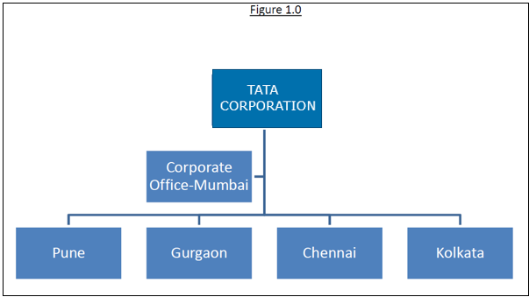

Overview: Organization has decided to implement ERP in order to bring

standardized system-based approach to business and optimum utilization of resources. It

also wants to benchmark and modify current business processes with Industry standard.

Following are the main Business objectives-

* Optimum utilization of resources (raw material, people, machine, finance, etc)
* Developing system driven approach to business rather than people dependent
* Developing real-time decision support system to manage volatile & fast changing
* market scenario
* Benchmarking of current business processes with Industry best practices
* Put system control on business sensitive information
* Developing Total visibility and improved process efficiency

**Project Scope for Materials Management:**

Organization follows Centralised approach for materials procurement and inventory management. While strategic souring is centralised to take advantage of volume, local vendors are looked after by divisional purchase departments. Following are the business scenarios which needs to be mapped in SAPS1- Operational procurement- Spares & Consumables

S2-Materials planning for Consumables which has definite consumption trend

S3-Organization has some hazards material which has expiry date. There is need to

track these materials separately along with monitoring of expiry date. Organization

wants to implement FIFO strategy for consumption of these items

S4-Organization has well defined Schedule of Authority (SOA) which is board

approved. There is separate SOA for Capex & Opex procurement(Refer Annexure08-

SOA Capex & Opex)

S5-There are some materials which are procured in domestic market and from

international market also. This is based on need and market availability. It is

observed that there is considerable difference in price for domestic and import

procurement. In order to reflect correct consumption values in P&L statement,

organization desires to valuate these materials differently and at the same time

wants to avoid duplication of material master data.

S6-Print & stationary items are difficult to quantify at the time of ordering.

Organization wants to have lumpsum contract with vendor with defined tolerance

for a particular period.

S7-Organization has highest priority for Customer delivery and it has implemented

many operational initiatives like JIT, KANBAN & Two-Bin system. These systems have

helped in improving operational efficiency and decreasing product delivery time. To

support these systems, organization has tied up with few vendors who have kept

their material in its store. This helps in material availability.

S8-For certain materials there are multiple suppliers. Organization wants to create

healthy competition in order to get the business. Based on certain quality

parameters, system should calculate the rating and one with favourable rating

should get the defined Quota of business.

S9-In order to avoid the low quality suppliers entering the vendor base, organization

wants to follow strict vendor registration process. The Central sourcing department

will own the vendor registration and after due diligence they would approve the

vendors for different plants.

S10-Organization wants to classify entire materials into A, B & C class based on their

inventory value. In order to have check between actual inventory and book

inventory, there is need of a robust physical inventory verification process in which

high value items will be reviewed more frequently compared to low value items.

S11-Certain materials are sent outside for specific process at vendor premises. This is

to take advantage of specific vendor expertise, to lower the cost of production and

increase the production capacity.

S12-Vendor payments are most important area in which Organization wants to

improve the visibility through availability of real time information on the status of

vendor payments.

S13-Organization wants to analyse the procurement of materials. Based on this

analysis, certain materials which are procured periodically by divisions will be shifted

to central procurement department in order to take advantage of volume discount.

S14-Central purchasing function wants, system to keep track of volume based

Discounts.

